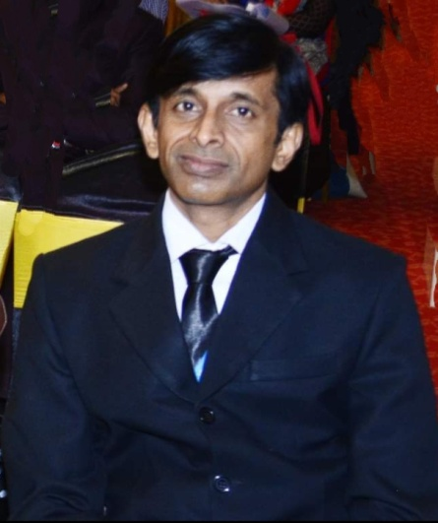

Name Dr. Sanjay Maheshwari

Designation Associate Professor

Qualification Ph.D,MBA(IT),M.Com, MA(Yoga),MA(Drawing),PG in Yoga,PGDCA